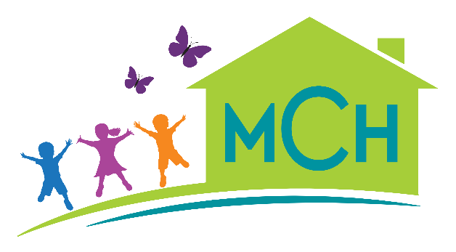 | Montessori Children’s House  2021-2022 Calendar
2021-2022 School Year
Date | Event | Notes
September 7 | School is open | First Day of School
November 11 | School is closed | Veterans’ Day
November 24  25 & 26 | School closes at 12  School is closed | Thanksgiving
December 6 | Progress Reports | Issued for all
December 22  December 23 – January 3 | School closes at 12  School closed | Winter break
January 17 | School is closed | Martin Luther King, Jr. Day
February 21 | School is closed | Presidents’ Day
April 11-15 | School is closed | Spring break
May 30 | School is closed | Memorial Day
June 15 | School closed at 12 | Last day of school
June 16 – 17 | School is closed | Teacher in service days
June 20 | School is closed | Juneteenth
June 22 | Progress Reports | Issued for all
June 21 | School is open | First day of summer session
July 4 | School is closed | Independence Day
August 29-September 2 | School is closed | Summer break

Short-Term Closures
Our calendar as planned has 184 instructional days. If MCH is required to close for 1-4 days due to weather, a case of Coronavirus at school, or other closure, we will not make up instructional days. If there are multiple short-term closures, we will use spring break for planned make-up days in order to reach 180 instructional days. However, we will follow all guidance from the Virginia Department of Health, so we may need to modify the plan based on their direction.
Coronavirus Longer-Term Closures
For closures lasting 5 consecutive school days or more, we will switch to distance learning.
Closures for Inclement Weather
Please note any inclement weather delays or closures will be announced on Channel 13. MCH does not always follow VBPS delays and closures. Provided we are able, MCH will also send out text, email and Facebook status regarding any delay or closure. Any delays would be from 8 a.m. For instance, a two hour delay would mean school begins at 10 a.m. No early morning care would be available.

